Computer Vision Assignment A1

# Question 1

$$P= \left({4 \atop \begin{aligned}-2 \\ 0\end{aligned}}\right)+t\left({0 \atop \begin{aligned}1 \\ 2\end{aligned}}\right)= \left({4 \atop \begin{aligned}-2+t \\ 2t\end{aligned}}\right)$$

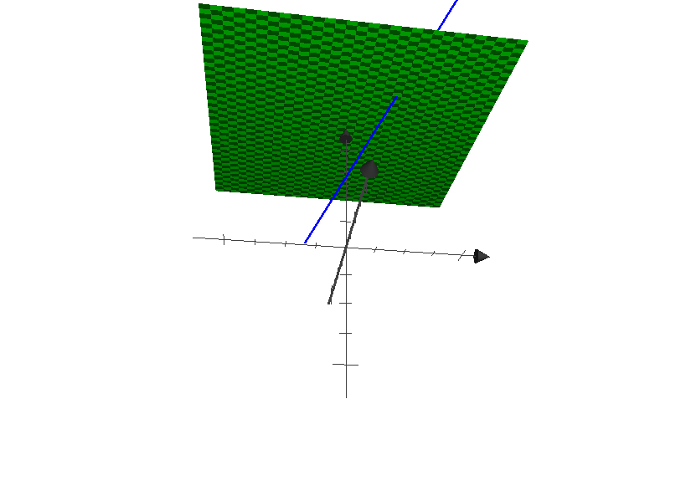

Figure Example projection when f' = 4

$$The projection will fall on the 2D image plane at \left(a,b,c\right)$$

$$∴$$

$$c=2t=f^{'}$$

$$t=\frac{f'}{2}$$

$$b= -2+t$$

$$b= -2+ \frac{f^{'}}{2}$$

$$a=4$$

$$∴ \left(a,b,c\right)= P^{'}=(4,-2+\frac{f^{'}}{2},f')$$

# Question 2

## Part 1

Use the Gaussian Lens Formula

$$\frac{1}{i}+\frac{1}{o}=\frac{1}{f}$$

Use the image magnification formula

$$\frac{h_{i}}{h_{o}}=-\frac{d_{i}}{d_{o}}=m$$

The lens must be placed a distance of $d_{o}$ away from the object and the relationship between $do and di$ is given by the following equation:

$$w=d_{o}+d_{i}=1.1m$$

Given that the projected image is half the size of the original object, we can solve for both $d_{o}$ and $d_{i}$.

$$m=\frac{h_{i}}{h_{o}}=\frac{1}{2}=-\frac{d_{i}}{d_{o}}$$

$$∴$$

$$d_{o}=-2d_{i}$$

$$Using the relationship between d_{o} and d_{i}: 2d_{i}=1.1-d_{i}$$

$$d_{i}=\frac{1.1}{3} → d_{o}=\frac{2.2}{3}$$

## Part 2

Use the Gaussian Lens Formula and the values derived above…

$$\frac{1}{d_{i}}+\frac{1}{d_{o}}=\frac{1}{f}$$

$$f= \frac{3}{1.1}+\frac{3}{2.2}=\frac{45}{11}$$

## Part 3

Solve the Blur Circle Diameter Equation

$$2r= \frac{A}{i^{'}}\left(i^{'}- i\right), where \left(i^{'}-i\right)= \frac{f}{(o^{'}-f)}+\frac{f}{(o-f)} (o-o^{'})$$

Given:

$$A=d$$

$$o^{'}=d_{o}+x$$

$$o=d_{o}$$

$$f=\frac{45}{11}$$

# Question 3

## Part 1

Apply local averaging filter